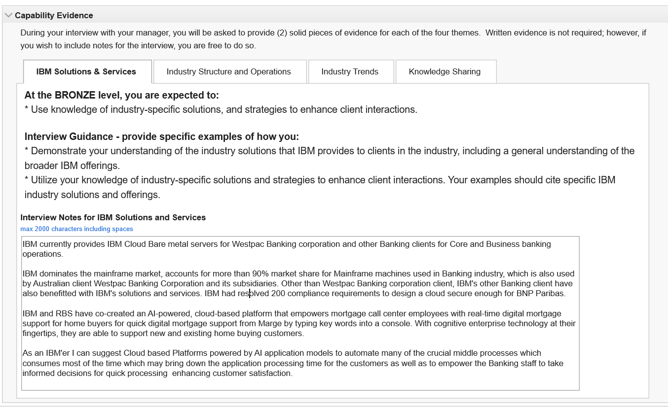

IBM currently provides IBM Cloud Bare metal servers for Westpac Banking corporation and other Banking clients for Core and Business banking operations.

IBM dominates the mainframe market, accounts for more than 90% market share for Mainframe machines used in Banking industry, which is also used by Westpac Banking Corporation and its subsidiaries.

IBM and RBS have co-created an AI-powered, cloud-based platform that empowers mortgage call center employees with real-time digital mortgage support for home buyers for quick digital mortgage support from Marge by typing key words into a console. With cognitive enterprise technology at their fingertips, they are able to support new and existing home buying customers.

Cloud based Platforms powered by AI application automate many of the crucial middle processes which consumes most of the time which may bring down the application processing time for the customers as well as to empower the Banking staff to take informed decisions for quick processing enhancing customer satisfaction.

As part of CLAS APRA PROJECT Interacted with client to successfully implement the solution to modify the mortgage template documents to reduce the debts partially by getting the acknowledgement and sign-off from the customer to reduce the debts from loan proceeds. This was done as part of APRA statutory compliance. Post customer approval the debts are reduced from the loan proceeds, thereby decreases the risk of NPA.

As part of CLAS TPDC PROJECT interacted with Client and implemented the changes to follow a Standard Model for the simplification of Broker commissions to comply with the ASIC requirements for Standard Model for Trailer and Referrer commission payments to Brokers by having 5 tiers of Commission in CLAS parameters. Brokers account for 47% of the lending in Banking Industry, the corresponding Commission Tiers are assigned based on the broker to satisfy the standard model as well as to cater for different categories of Brokers.

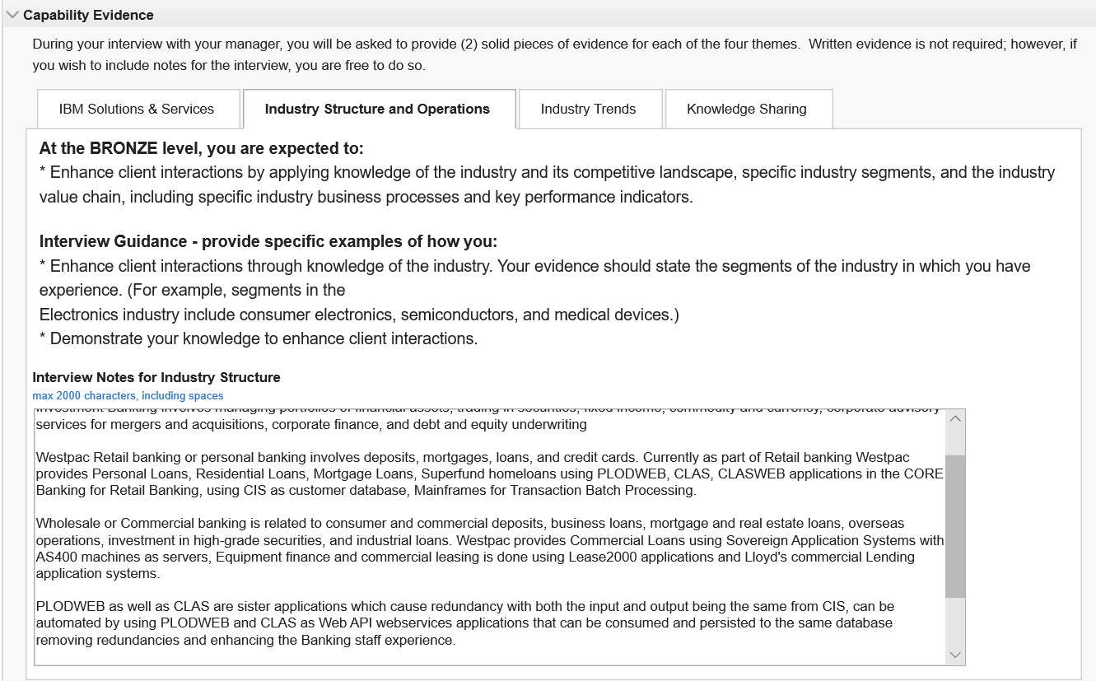

Westpac's three main business segments of banking sectors are Retail Banking, Commercial Banking, and Investment Banking.

Investment Banking involves managing portfolios of financial assets, trading in securities, fixed income, commodity and currency, corporate advisory services for mergers and acquisitions, corporate finance, and debt and equity underwriting

Westpac Retail banking or personal banking involves deposits, mortgages, loans, and credit cards. Currently as part of Retail banking Westpac provides Personal Loans, Residential Loans, Mortgage Loans, Superfund loans using PLODWEB, CLAS, CLASWEB applications in the CORE Banking for Retail Banking, using CIS customer database, Mainframes for Transaction Batch Processing.

Wholesale or Commercial banking is related to consumer and commercial deposits, business loans, mortgage and real estate loans, overseas operations, investment in high-grade securities, and industrial loans. Westpac provides Commercial Loans using Sovereign Application Systems, Equipment finance and commercial leasing is done using Lease2000 applications and Lloyd's commercial Lending application systems.

As part of CLAS APRA Project interacted with client to modify CLAS WEB API to utilize the CLAS services to process the input from EL Web Submission which will trigger the CLAS INI generation to create CLAS INI variables files that are consumed by CLAS templates to generate the customer output documents for CLAS EL just like CLAS application there by avoiding redundancy of form online submissions for Banking customers.

As part of CLAS NMD PROJECT interacted with client and Implemented the changes to National Mortgage Form to make it compliant with the ARNECC requirement, by implementing the Mortgage Execution Acknowledgement for the ACT state with Witness certification so that the bank can be legally compliant as well as reduce the risk of unclear mortgage proprietorship for Loans origination from ACT state of Australia.

**Next suggestion to Westpac is to integrate PLODWEB Web API interfaces with CLAS Web API, just like CLAS as both PLODWEB and CLAS are sister applications which cause redundancy with both the input and output being the same from CIS, can be automated by using PLODWEB and CLAS as Web API webservices applications that can be consumed and persisted to the same database removing redundancies and enhancing the Banking staff experience.**

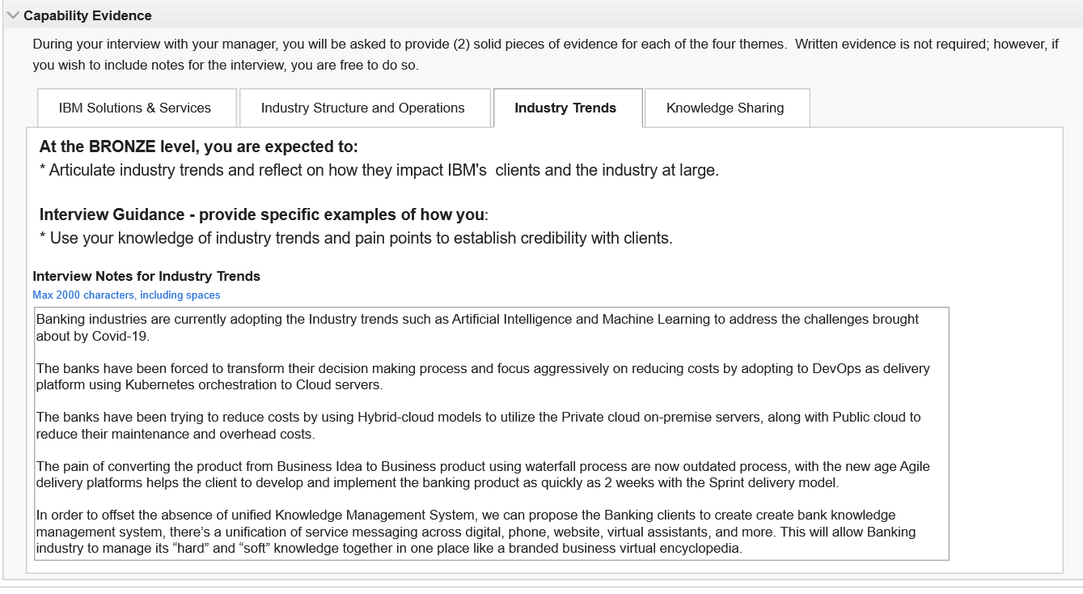

Banking industries are currently adopting the Industry trends such as Artificial Intelligence and Machine Learning to address the challenges brought about by Covid-19.

The banks have been forced to transform their decision making process and focus aggressively on reducing costs by adopting to DevOps as delivery platform using Kubernetes orchestration to Cloud servers.

The banks have been trying to reduce costs by using Hybrid-cloud models to utilize the Private cloud on-premise servers, along with Public cloud to reduce their maintenance and overhead costs.

The pain of converting the product from Business Idea to Business product using waterfall process are now outdated process, with the new age Agile delivery platforms helps the client to develop and implement the banking product as quickly as 2 weeks with the Sprint delivery model.

In order to offset the absence of unified Knowledge Management System, we can propose the Banking clients to create create bank knowledge management system, there’s a unification of service messaging across digital, phone, website, virtual assistants, and more. This will allow Banking industry to manage its “hard” and “soft” knowledge together in one place like a branded business virtual encyclopedia.

As more and more from banking industry are trying to upgrade as well as reduce the cost of technological services provided to the consumers. Microservices as SOA has turned out to be the prime choice for many along with containerization as this is the future of the Applications to integrate different types of devices which are mobile, tablet, PC’s, and wearable devices like watches. Westpac has started focusing on the same. Which then helps the banks to target the future consumers by providing one minute loan offerings, one touch mortgage products, and thereby leveraging their market share.

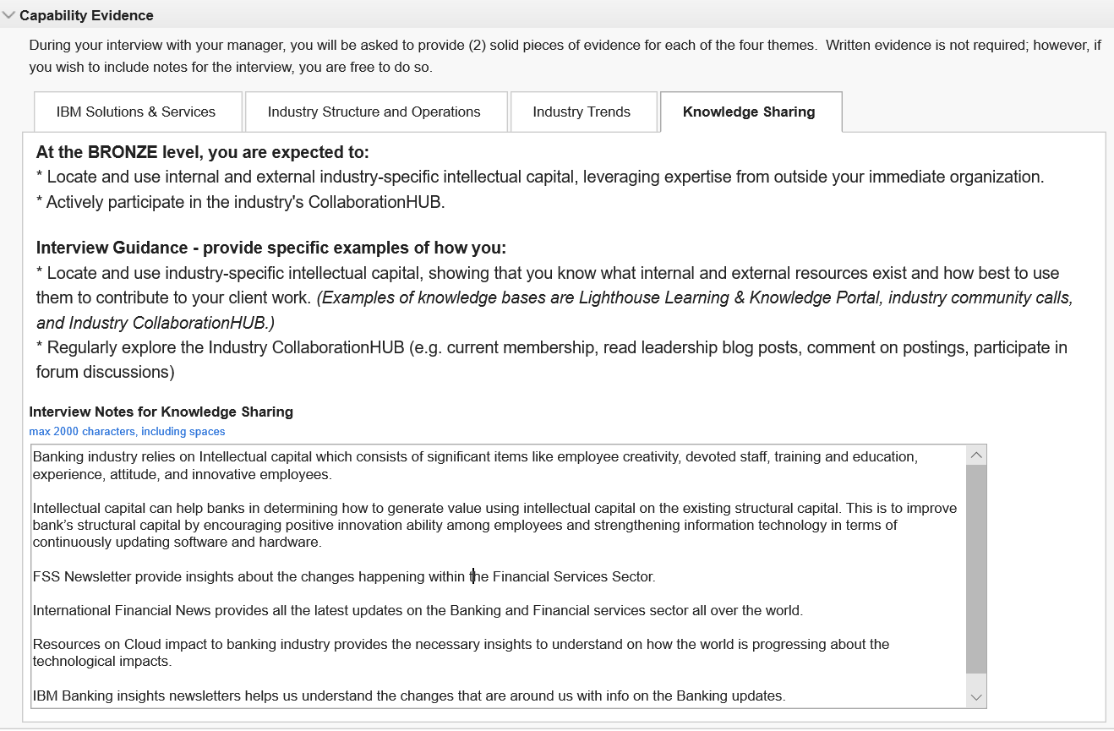

Banking industry relies on Intellectual capital which consists of significant items like employee creativity, devoted staff, training and education, experience, attitude, and innovative employees.

Intellectual capital can help banks in determining how to generate value using intellectual capital on the existing structural capital. This is to improve bank’s structural capital by encouraging positive innovation ability among employees and strengthening information technology in terms of continuously updating software and hardware.

FSS Newsletters provide insights about the changes happening within the Financial Services Sector.

International Financial News provides all the latest updates on the Banking and Financial services sector all over the world.

News portals like Bloomberg, MoneyControl.com, worldretailbankingreport.com, thefinancialbrand.com news channels provide continues trends, and digital eco system of the Banking Industry and the challenges and opportunities it provide the resources to become digital financial technology organizations.

Resources on Cloud impact to banking industry provides the necessary insights to understand on how the world is progressing about the technological impacts.

IBM Banking insights newsletters helps us understand the changes that are around us with info on the Banking updates.